Stock Paper Trader

The three main states of the app:

1. Looking at the slope of the current price
2. Buying and staying in then selling
3. Buying and selling immediately

Logic Diagram:

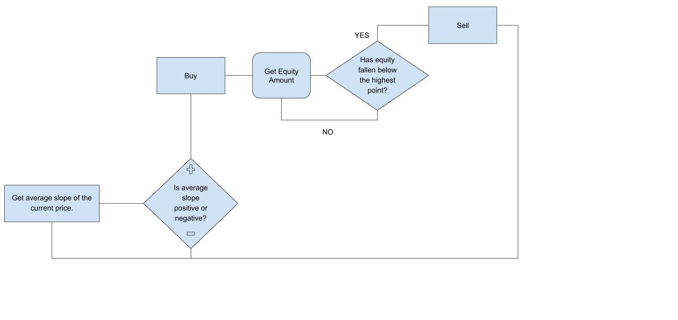

10/28/2020

